V8 device Firmware upgrade

- Open Firmware upgrade tool “V8FirmwareTools_V0xxx.exe” (Download from Web)
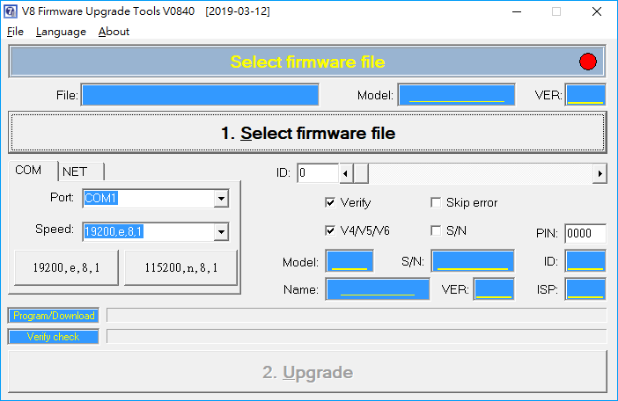
- Select SYB firmware file (ex. SYTD2N-U1_V0853_20200107.SYB)
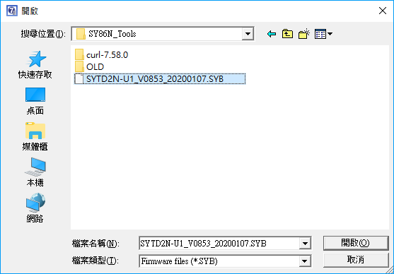
- Find device IP address and upgrade with TCP connection (RJ-45)
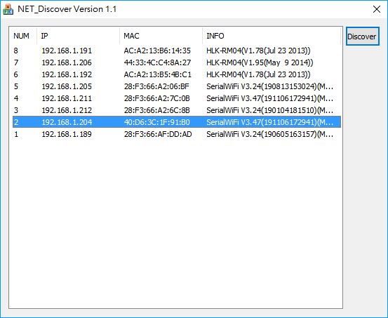
- Upgrade. (Verify should be selected.)
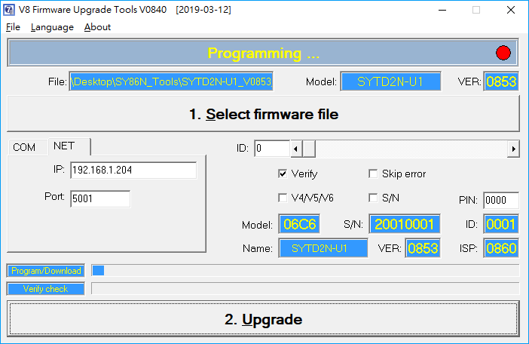
PS. If the upgrade fails, you can retry until successful.
But do not restart the device or replug the power supply.
- Upgrade OK
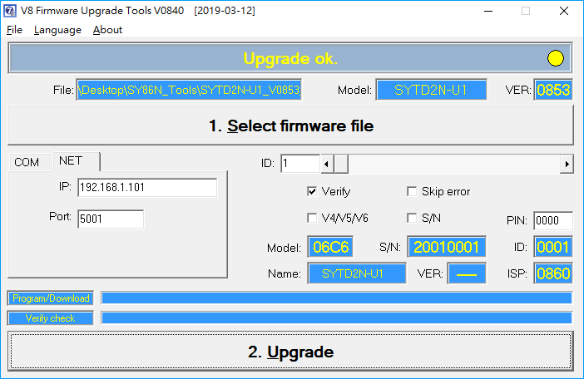
- Open utility to check firmware version
